PPM GC7 Best Practices and Success stories Trans-Nzoia County

Project Name | GFTB_PPM_GC7
Location | Jetty Hospital, Cherangany Subcounty, Trans Nzoia County
Intervention Area | TB Active Case Finding, Treatment and Integrated HIV/TB Services
Activity | Mentorship, support supervision, facility-based CMEs and OJT
Implementing partners | County and Subcounty TB team, NEPHAK

Background
Jetty Hospital, a private facility in Cherangany Subcounty, was previously not offering TB services despite serving a high patient load. This created a missed opportunity for early TB case detection and management within the community.
Intervention
Through coordinated engagement by the County TB Program, Subcounty TB Team, and the NEPHAK Program Assistant, the facility received:
- Targeted mentorship on TB screening and case management
- A facility-based Continuous Medical Education (CME) session
- Support to establish routine TB symptom screening
- Strengthening of on-site sputum microscopy services
- Linkage to a sample referral system for molecular testing using engaged riders
Results
Following these interventions, the facility institutionalized routine TB screening for all clients and enhanced its diagnostic capacity.
A significant outcome was the identification of a pregnant woman who was a household contact of her husband diagnosed with TB. Initially, her first sputum test was negative, and she was not started on TB preventive therapy. However, due to continued clinical vigilance and follow-up, a repeat test conducted one month later confirmed TB disease.
The patient was promptly initiated on TB treatment. Further evaluation also led to a diagnosis of HIV, enabling early linkage to comprehensive HIV care. Early initiation of integrated TB/HIV treatment improved her prognosis and reduced the risk of transmission to her unborn child and household contacts.
Key Achievements
- Activation of TB services in a previously non-reporting private facility
- Improved TB screening and diagnostic capacity
- Identification of 8 TB cases
- Facility made a TB diagnostic and treatment facility
- Strengthened sample referral system for molecular testing
- Early detection of TB and HIV in a high-risk pregnant mother
- Enhanced public-private collaboration in TB case finding
Conclusion
Jetty Hospital’s transformation demonstrates the impact of structured mentorship, capacity building, and strong public-private engagement in expanding TB service delivery. The facility is now contributing to increased TB case detection and improved patient outcomes in Cherangany Subcounty

Activity Photos
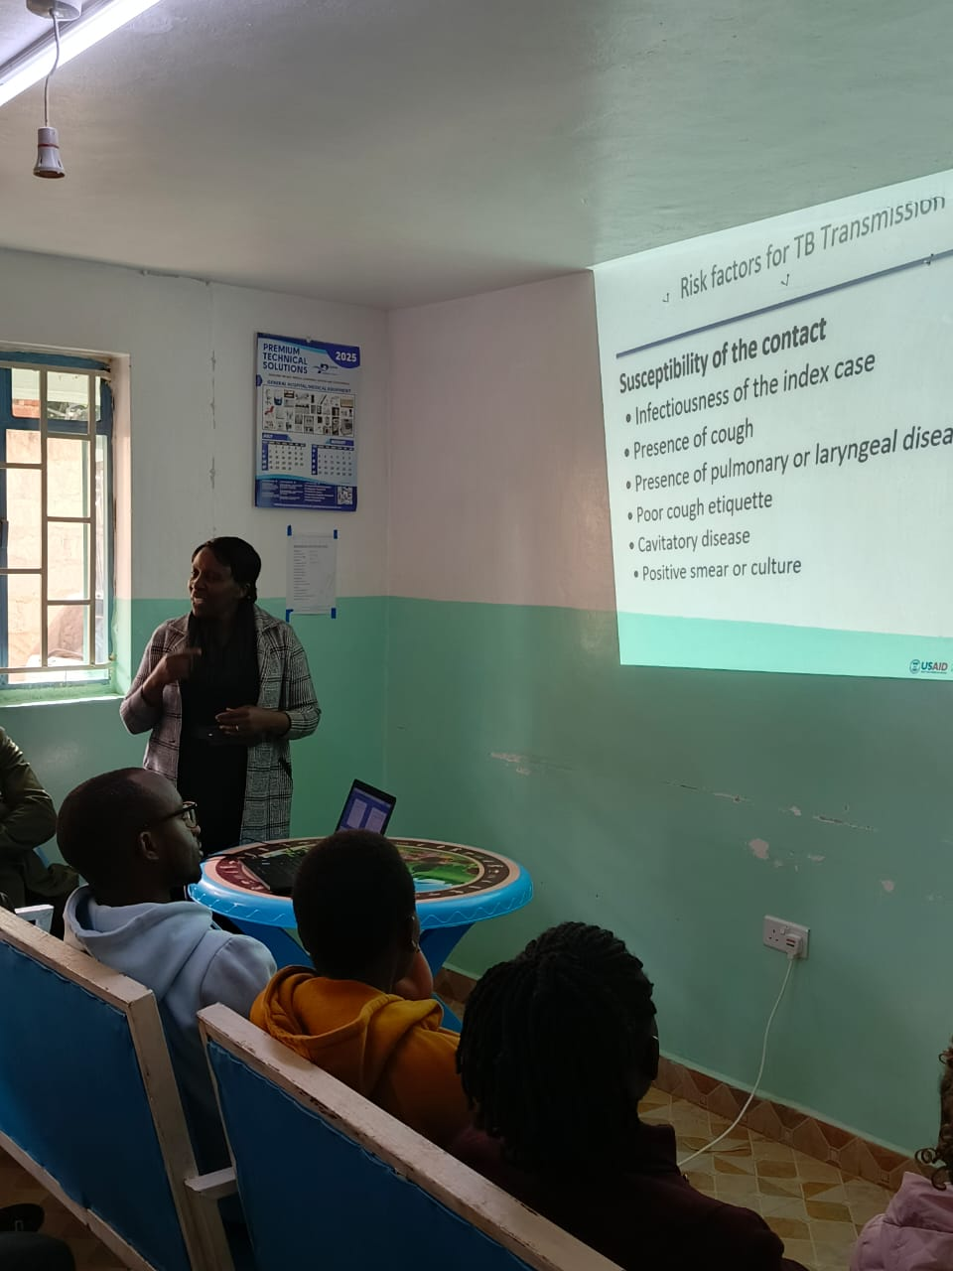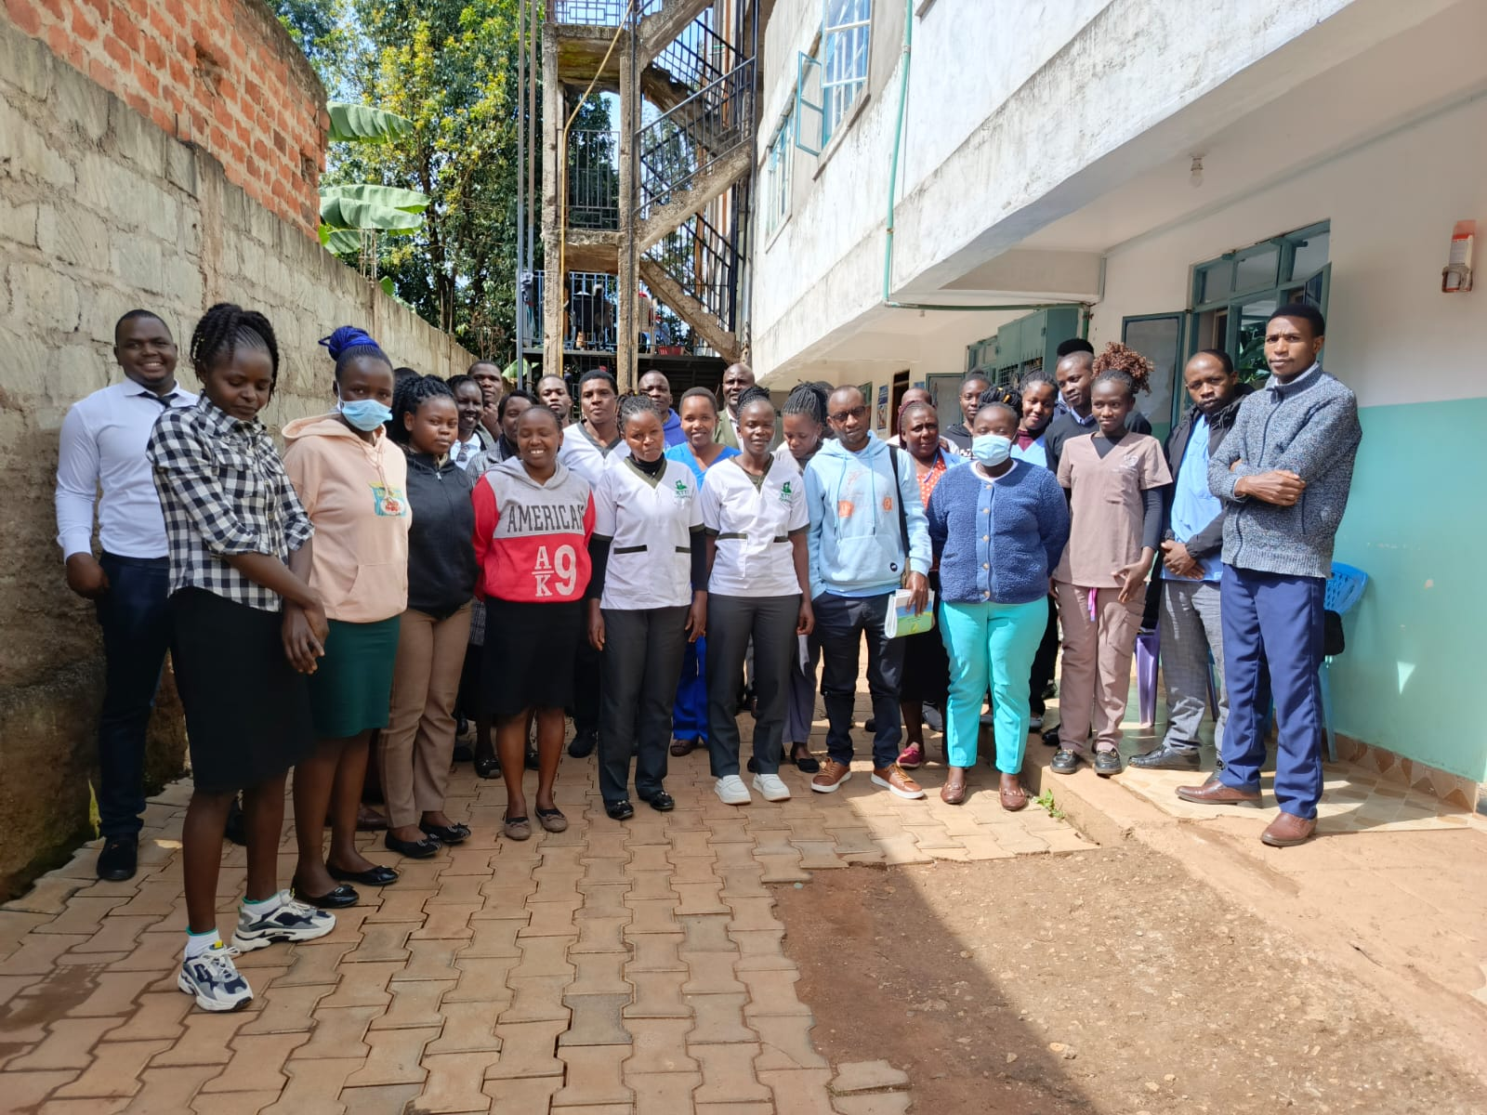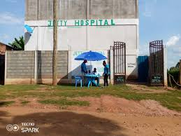
Fig Top Left: An ongoing Facility CME at Jetty Hospital
Fig Top Right: Group photo with health care workers after the CME
Fig Bottom Left: Link desk for systematic TB screening outside the facility

