KEY HIGHLIGHTS OF 2025 SUCCESS
NEPHAK is a national network representing People Living with HIV (PLHIV) and affected communities in Kenya, with an operational footprint in 47 counties. The organization works at the intersection of service delivery, advocacy, human rights, and health systems accountability, positioning communities as both beneficiaries and co-producers of health outcomes.
NEPHAK’s core mandate is to strengthen community systems to improve access, quality, and equity in HIV, TB, and related health services. This is achieved through partnerships with national and county governments, donors, civil society organizations, private health providers, and community-based structures.
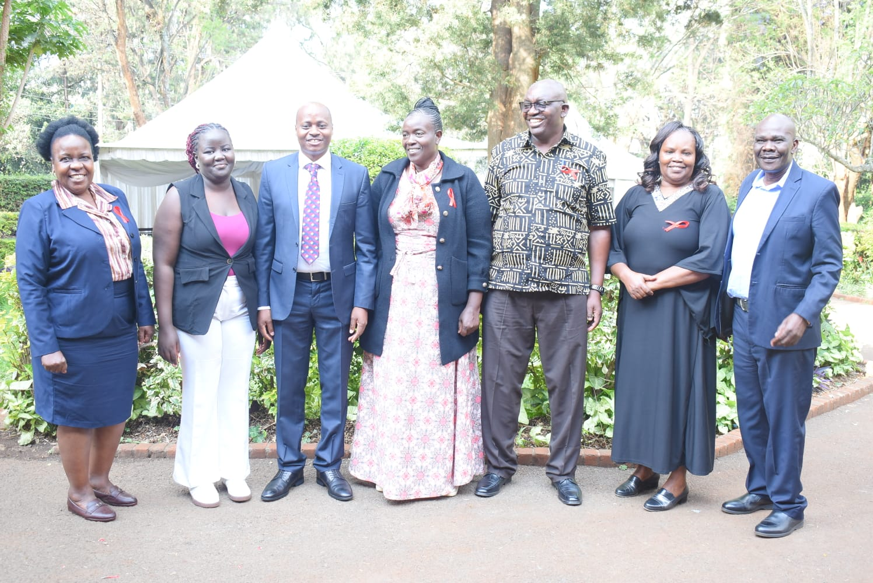
NEPHAK Board Members together with Dr. Mulwa Head of Nascop

In 2025, NEPHAK partnered with institutions including Kenya Red Cross Society, Amref Health Africa, AFROCAB, GNP+, and county health departments to implement integrated HIV and TB interventions. Its operational model is anchored in peer leadership, decentralized implementation, and rights-based programming aligned with national strategies and global commitments such as WHO 95–95–95 targets and Universal Health Coverage (UHC).

Advanced HIV Disease (AHD)
Implemented with AFROCAB and GNP+, the AHD program strengthened survivor-led advocacy, early diagnosis, and psychosocial support across 10 facilities in 5 counties. The initiative trained 71 AHD champions, formed 24 support groups, and improved linkages between communities and facilities, contributing to reduced stigma and improved referral pathways.

We have had successful TB Engagement
TB Engagement di
TB Program (Global Fund TB – PPM & Community TB)
NEPHAK’s TB portfolio combined Public-Private Mix (PPM) and community-based TB interventions across 11 counties.
PPM: Engaged 337 private facilities (99% reporting compliance), trained 247 healthcare workers and 238 lab staff, deployed 41 riders and 50 Link Assistants, and strengthened referral and sample transport networks.
Community TB: Focused on contact tracing, pediatric TB, treatment adherence, and social protection. While CHP capacity was strong, operational constraints limited contact tracing (66%) and pediatric X-ray uptake (28%).

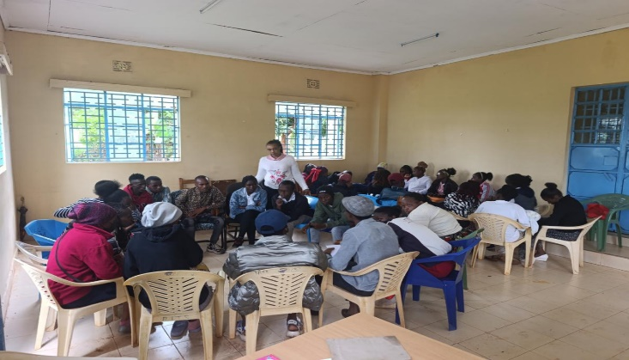

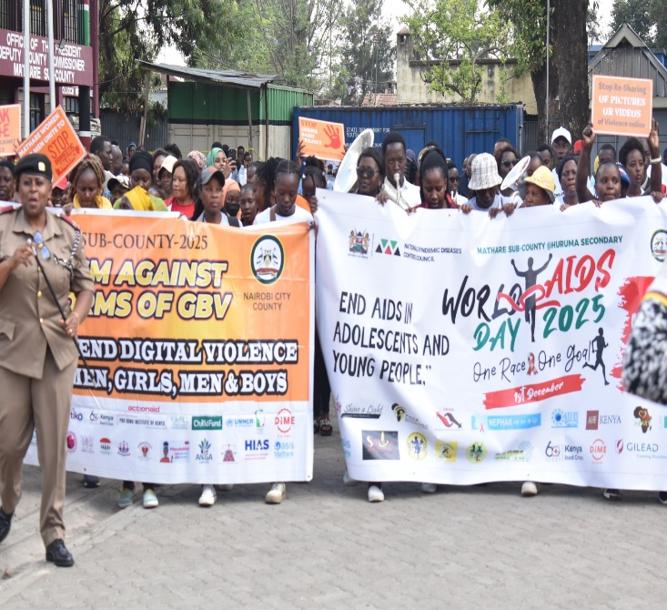
Engagement of World Aids
We have had successful engagement of Communities during world Aids Day

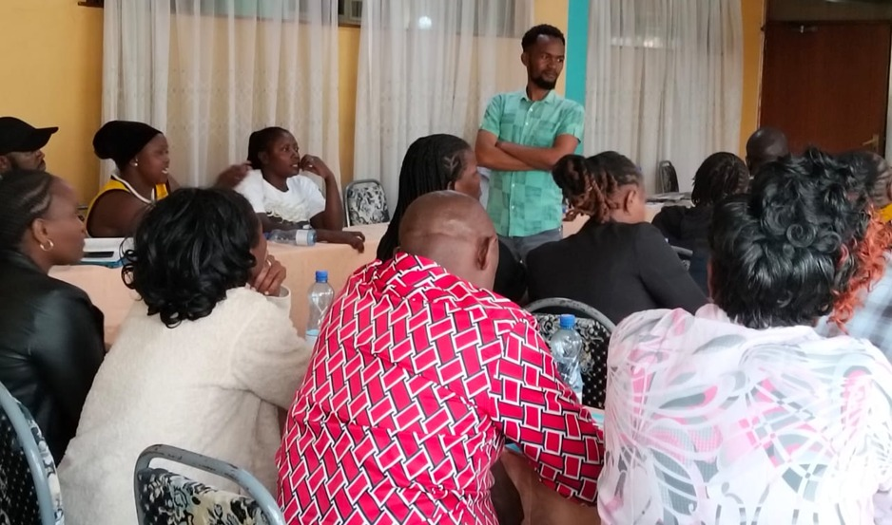
Community engagement dialogue

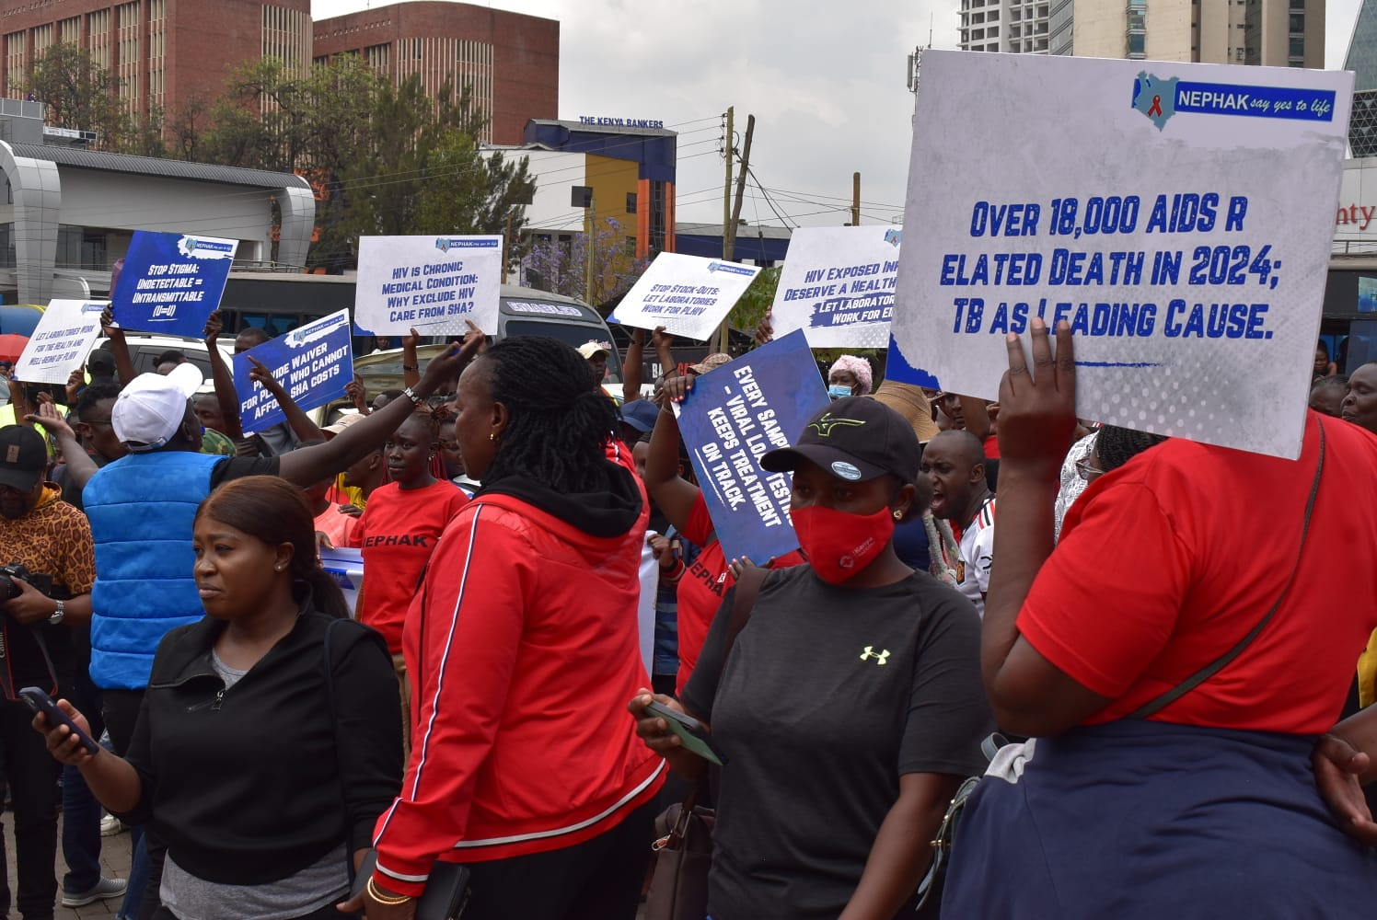
NEPHAK Members engaged in the INTERGRATION OF HIV CARE DISCUSSION

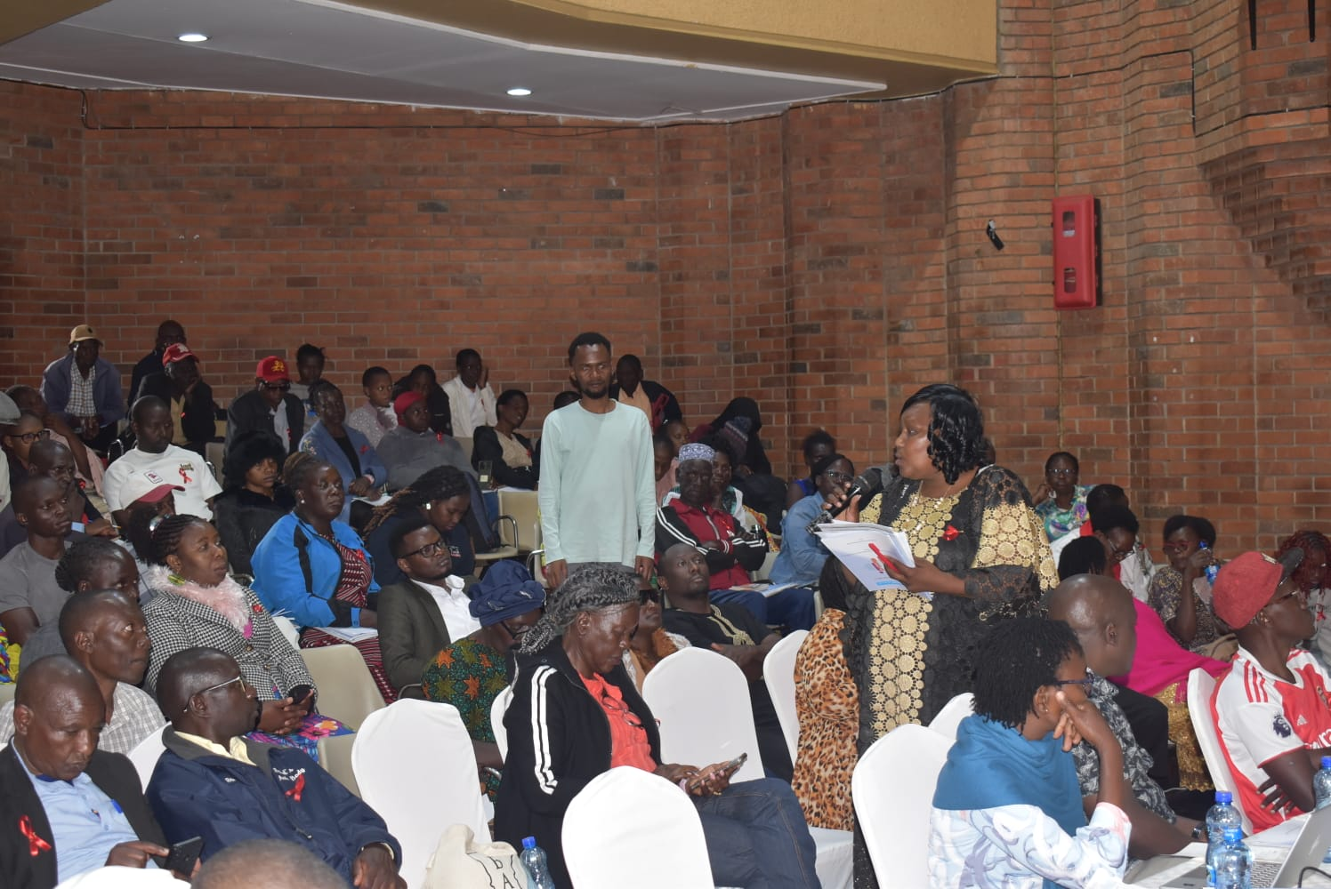

NEPHAK members gathered for the Annual meeting and finding updates from what has worked and what didn’t work.

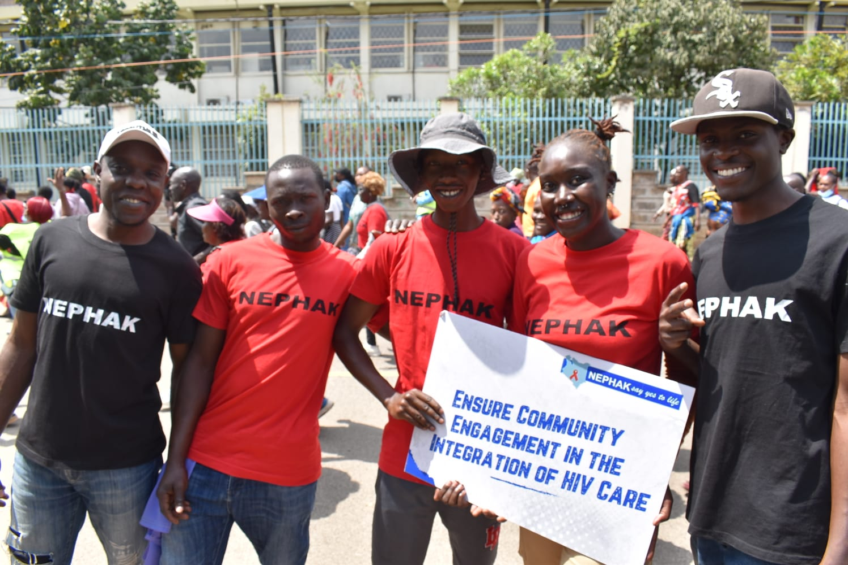

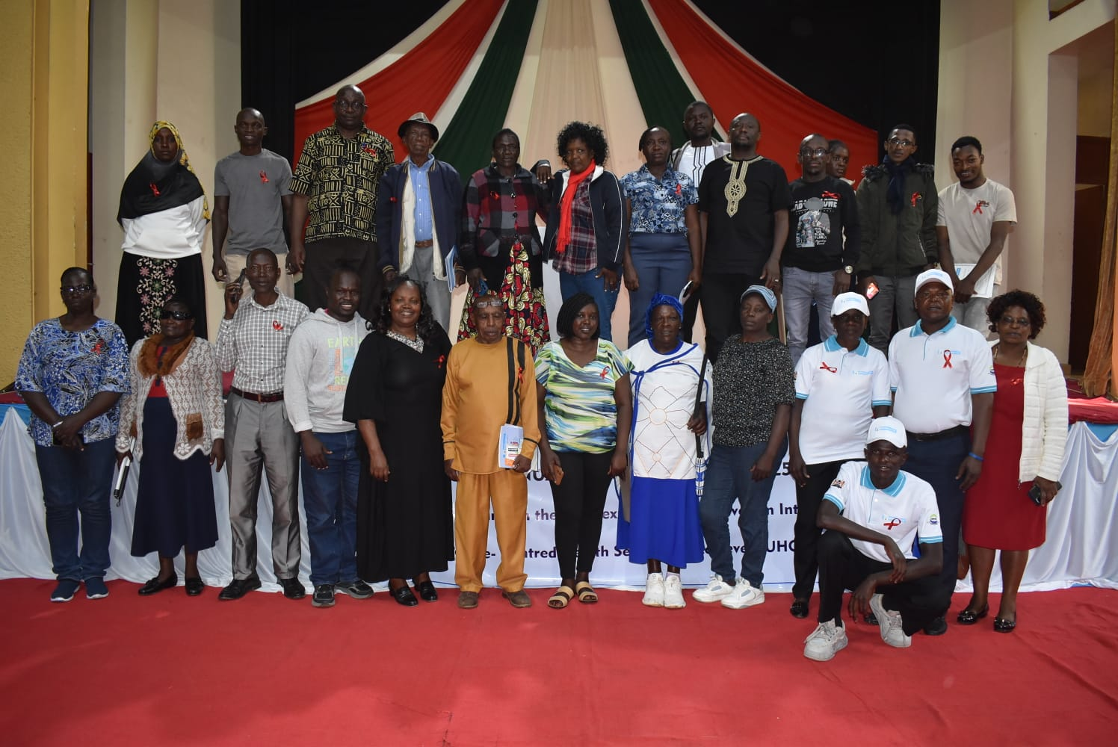

The 2025 NEPHAK HIV Program has demonstrated that community-led monitoring and response are vital for reaching the "last mile" in HIV care. While treatment re-integration and human rights advocacy have seen record successes, 2026 must focus on closing the gaps in the HEI cascade and ensuring the sustainability of community cadres.

ADVANCED HIV DISEASE (AHD)
The primary goal of the Last Mile Grant Initiative and the AFROCAB - NEPHAK AHD Project is to reduce morbidity and mortality from Advanced HIV Disease (AHD) by strengthening community-led advocacy and early clinical intervention.
Specific objectives:
Advocacy & Leadership: To understand the needs of PLHIV with AHD and promote meaningful community leadership and representation.
Capacity & Policy: To build advocacy capacity at all levels and influence policy, programming, and resource allocation.
Clinical Outcomes: To improve timely diagnosis and treatment while reducing referral times by 30%.
Service Quality: To achieve over 80% patient satisfaction through trained health workers and Community Health Workers (CHWs).
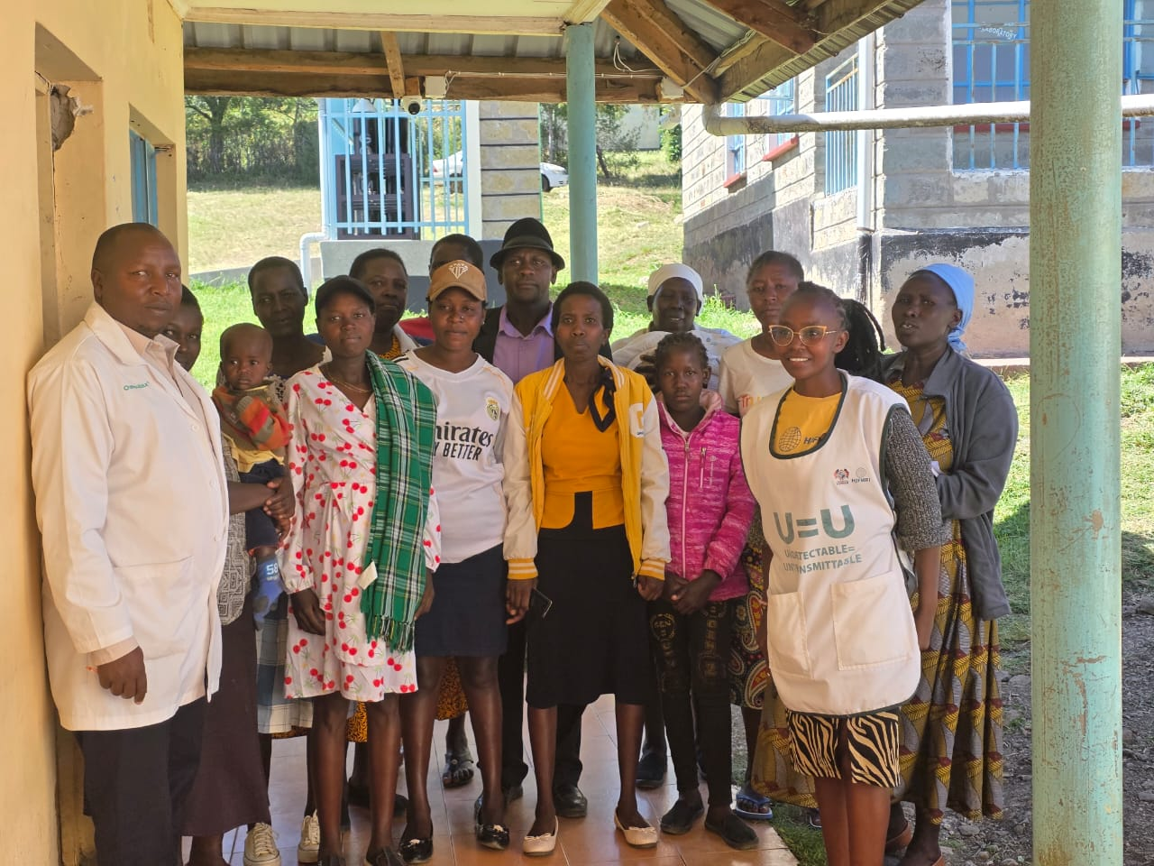

TB PROGRAM
Integrated TB Program Report (PPM & Community TB) 2025
Program Focus and Objectives
The NEPHAK-implemented Global Fund TB (GFTB) Project, funded through Amref, supports Kenya’s National TB Program by enhancing case detection and treatment success across private and community sectors. The initiative aligns with four key Global Fund modules: Case Finding, Treatment and Care, Community Systems Strengthening (CSS), and Human Rights/Gender (HRG) barriers.

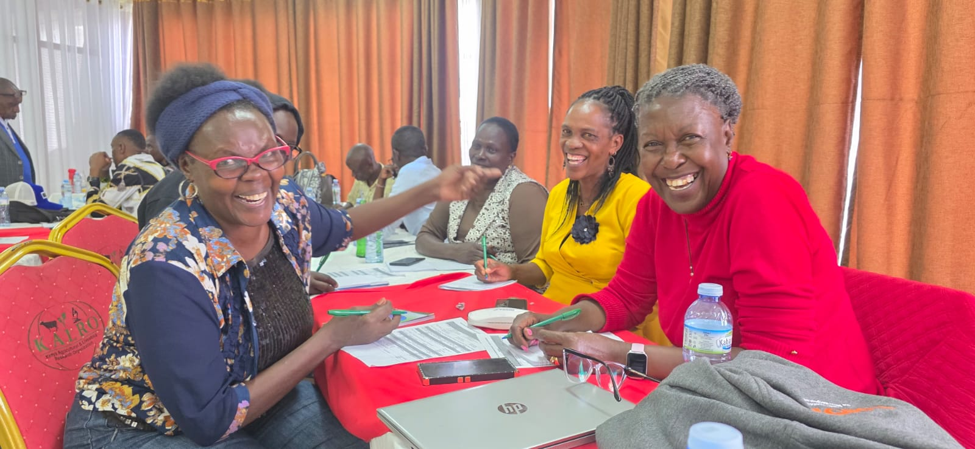
COMMUNITY VOICES MATTER
Communities are the voices for tomorrow hence they must be included and they are part and parcel of every decision because our health is our priority.

