Program Activity Updates & Highlights
Global Fund TB Public-Private Mix (GFTB GC7-PPM) — Trans Nzoia County

Program Name | Global Fund Tuberculosis Public-Private Mix (GFTB-PPM)
Activity | Laboratory Diagnosis & Stepwise Diagnostic Testing Training for Laboratory Staff in engaged private facilities
Location / County | Trans Nzoia County
Date | 19th to 21st May 2025

Brief Summary of the Activity
As part of NEPHAK's strategic initiative to enhance tuberculosis diagnostics under the Global Fund GC7 Grant, a rigorous 3 days sensitization and hands-on laboratory diagnostic training was conducted in collaboration with the Trans Nzoia department of Health, for laboratory professionals from engaged private facilities and public molecular diagnostic facilities in Trans Nzoia County. The training specialized in building local capacity for microscopic smear examinations, standardized sample preparation, and safeguarding biosafety during laboratory diagnosis. Crucially, the participants were trained on the implementation of stepwise diagnostic pathways: conducting initial smear microscopy testing at local private/faith-based facilities, followed by the systematic packaging and referral of eligible specimens to Molecular GeneXpert and TRU NAT hub labs through a dedicated sample networking by engaged riders to ensure comprehensive drug resistance testing.
Key Outcomes and Programmatic Impact
- Exceptional Target Achievement: This specific laboratory diagnostic capacity building and targeted diagnostic expansion directly drove Trans Nzoia County to surpass its case detection targets, achieving an outstanding 130% target performance in the latest performance review on April 2026
- Enhanced Diagnostic Capacity: A cohort of 22 laboratory staff from local private and faith-based health facilities were successfully upskilled enhancing diagnosis at facility level and sample networking for molecular TB testing. This also helped the county to increase on the number of facilities doing TB diagnosis by facilitating 2 more private facilities to become diagnostic facilities through onsite job training and provision of TB testing slides and reagents by the subcounty medical laboratory coordinators
- Operationalized the "Stepwise Testing" Pathway
The training bridged the gap between basic facility-level testing and advanced molecular testing. Medical laboratory staff were trained to conduct initial smear microscopy testing directly onsite at their respective private facilities after which they could then refer the samples through an established sample networking by riders to molecular Gene Xpert and TRU NAT hub laboratories for drug sensitivity testing. The results are then relayed back to the referring facility for patient management
- Optimized Diagnostic and treatment Timelines: The training successfully operationalized the facility-to-molecular-hub referral networks through engaged riders by ensuring high-quality primary smear analysis locally, the referral and processing times for advanced GeneXpert diagnostics were reduced by an estimated 24 hours, facilitating quicker treatment initiation.

Photos & Creative Captions

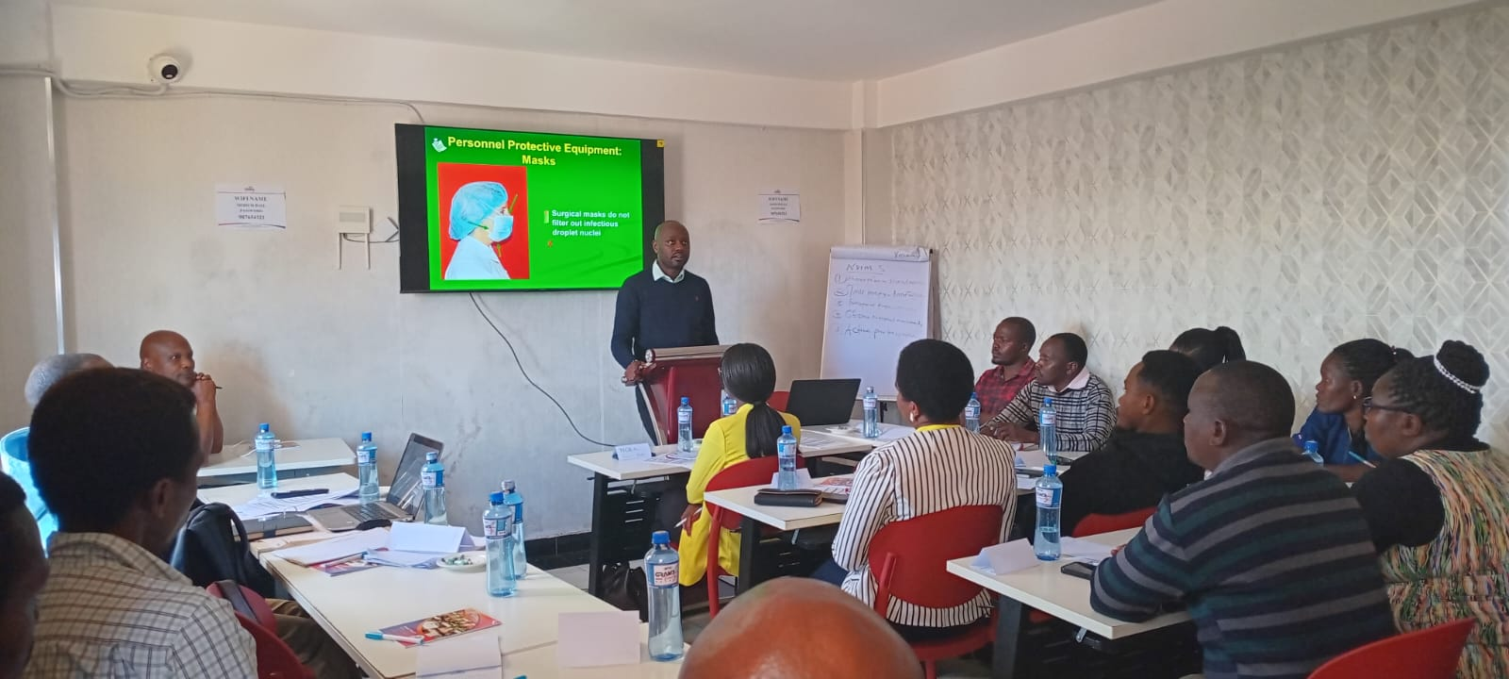
Fig 1.0 The County Director of Health Addressing Laboratory staff from the engaged private facilities for official opening of the training
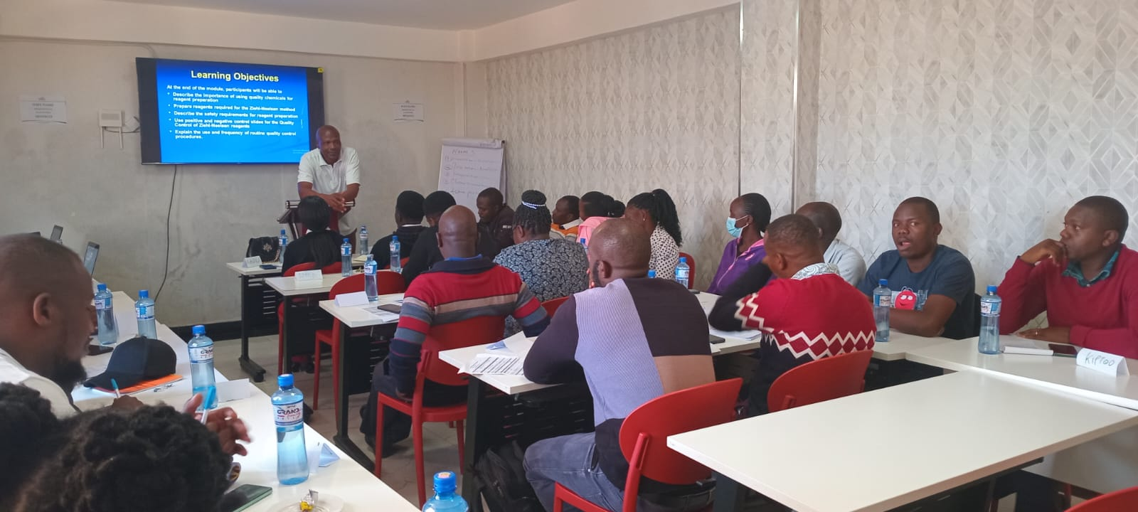
Fig 2.0 Medical Laboratory staff from the engaged private facilities during the training on TB diagnosis
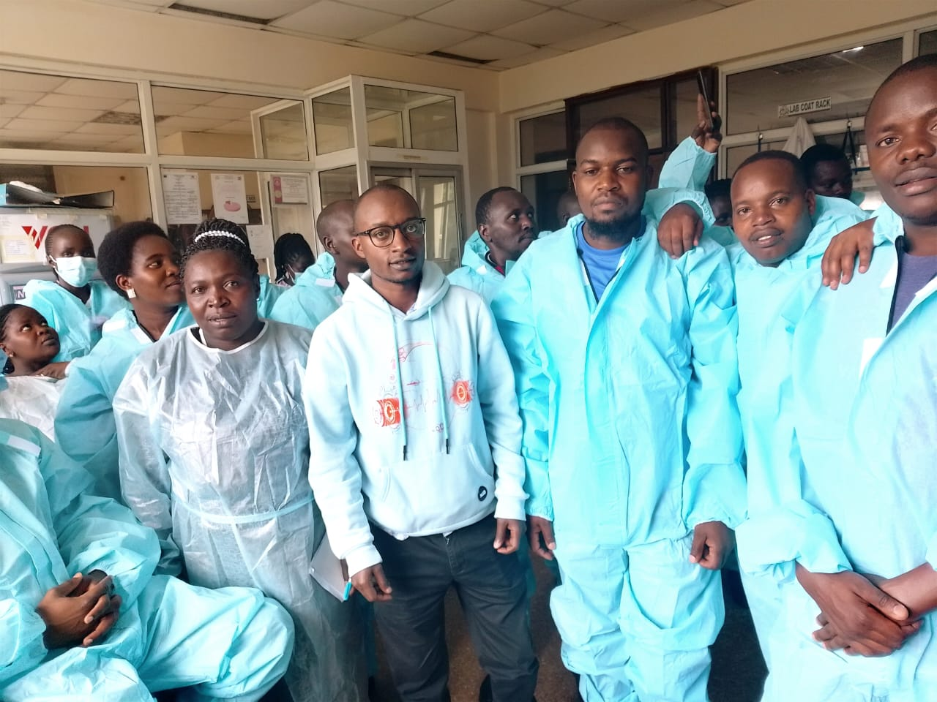
Fig 3.0 Medical laboratory staff with NEPHAK Staff at the TB Laboratory at the Kitale Regional Public Health Laboratory for practical sessions on TB diagnosis through ZN, GENE XPERT, LF LAM and LPA

